Understanding Good Care EasyRead Questionnaire
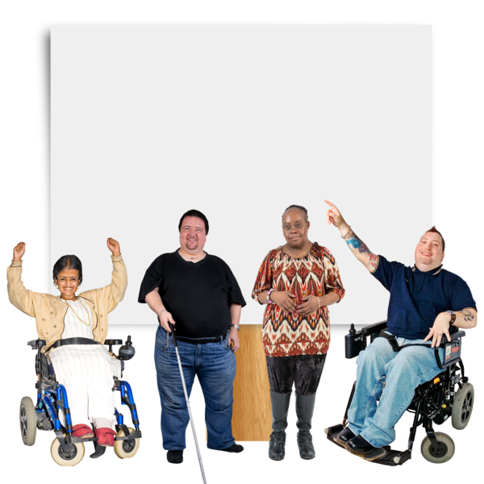Four disabled people in front of a white screen. | Difference North East is a disabled people’s organisation.
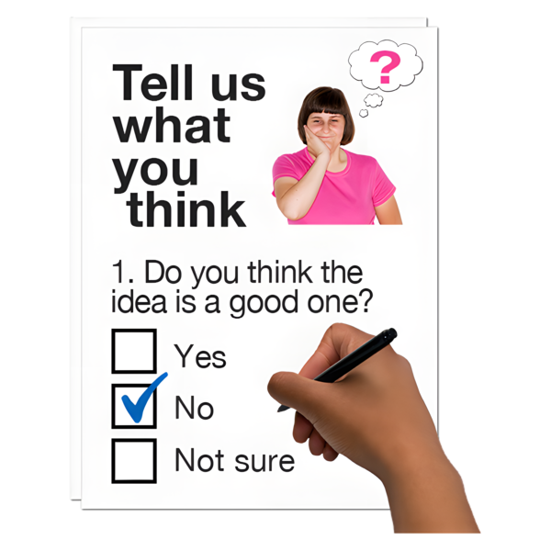 Hand marking 'No' on a survey form titled 'Tell us what you think'. | This is a questionnaire about what good care looks like for disabled people.
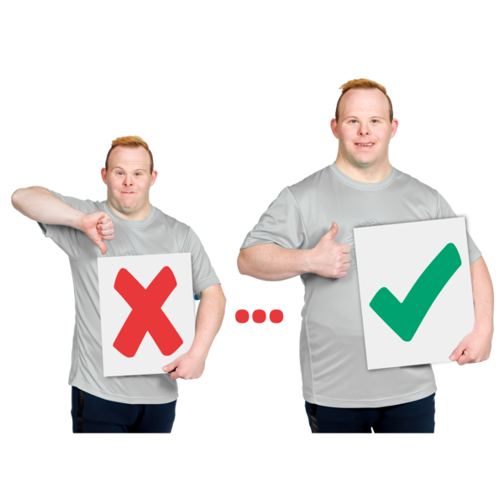Two men holding signs with thumbs up and thumbs down gestures. | Your responses will be used to try and make things better.
 Silhouette of a person's head and shoulders. | We will not tell anybody that you have filled in this questionnaire. It is anonymous.
 Laptop screen displaying an envelope with the word 'e-mail' on a blue background. | If you want to ask any questions about this study, just email Christopher@differencenortheast.org.uk

Pictures | Questions | Write your answer here
Section 1 - About You
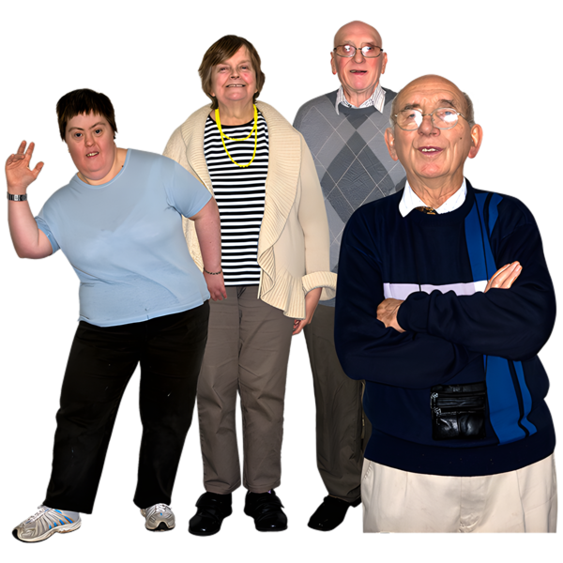Group of people of different ages | How old are you? | Write it down here  ……………………………
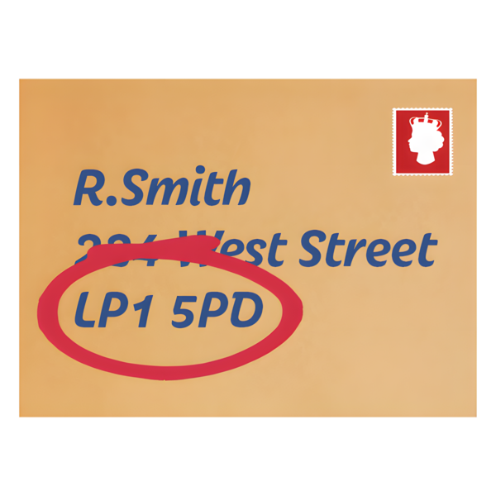A letter with the postcode highlighted in red | What is your postcode? | Write it down here  ……………………………
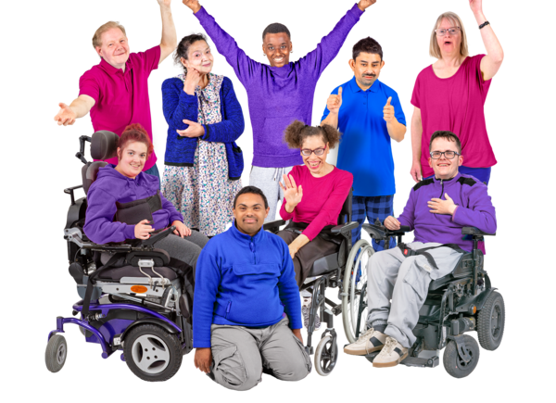People with different types of conditions | How would you describe your disability? | Choose from ….  ☐ Learning difficulties  ☐ Physical impairments  ☐ Neurodivergent  ☐ Mental health  Or write it down here  ……………………………

Section 2 - Your Care and Support
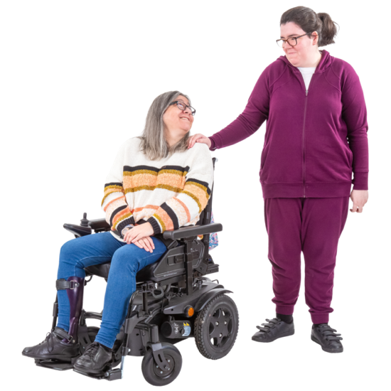 Person in a wheelchair smiling at another person standing beside them with a hand on their shoulder. | Who gives you care? | Choose from  ☐ Personal Assistant(s)  ☐ Care agency / care worker  ☐ Supported living service  ☐ Residential care  ☐ Partner  ☐ Family member  ☐ Friend  ☐ NHS or health service  ☐ Another person or service  Or write something here  ……………………………
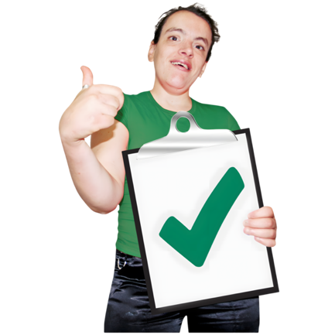    Person holding a questionnaire and another with a clipboard with a green tick | What is it like when you get care? | 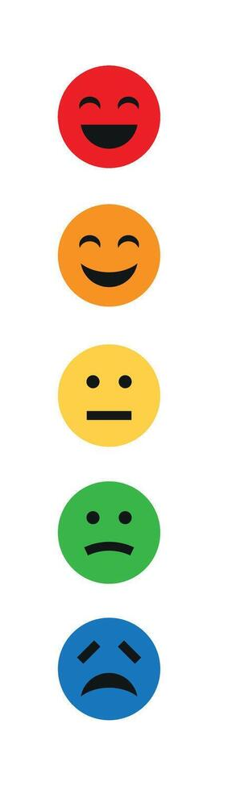  Please select from …  Very good  Not very good  Okay  Not okay  Terrible
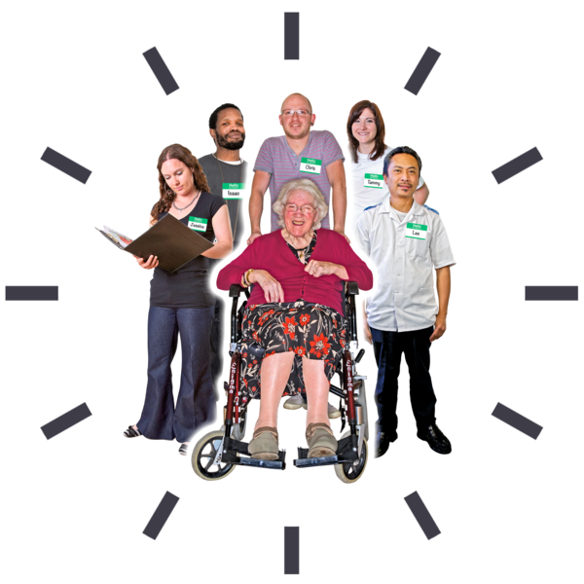A diverse group of people including an elderly woman in a wheelchair, surrounded by five adults with name tags. | How do you describe your care? | Choose from …  ☐ Respectful  ☐ Reliable  ☐ Kind  ☐ Encouraging  ☐ Flexible  ☐ Safe  ☐ Dignified  ☐ Enables my independence  ☐ Person-centred  ☐ Controlling  ☐ Rushed  ☐ Inconsistent  ☐ Unpredictable  ☐ Dismissive  ☐ Other: ______________________________

Section 3 - Choice and Control
  A group of six diverse people standing together with name tags. | Can you choose who gives you care? | Choose from ….  ☐ Yes  ☐ No  ☐ Don’t know  Or write something to explain here  ……………………………………………………………………
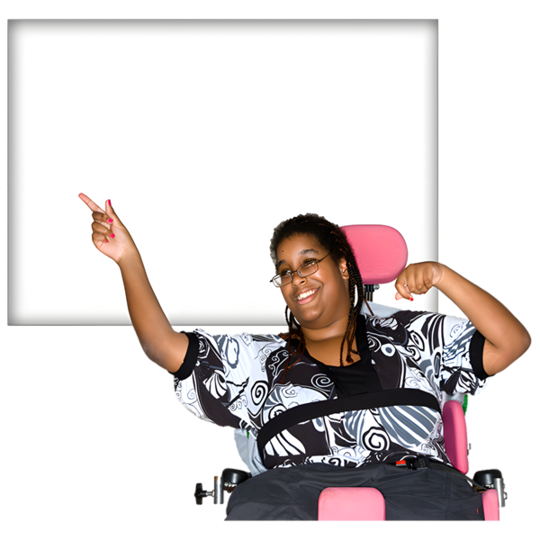Person in a wheelchair pointing upwards and smiling. | Can you decide what your carers do for you? | Please choose from …  ☐ I have complete control  ☐ I have quite a lot of control  ☐ I have some control  ☐ I have very little control  ☐ I have no control  ☐ This is not applicable  Or write something to explain here  ……………………………………………………………………
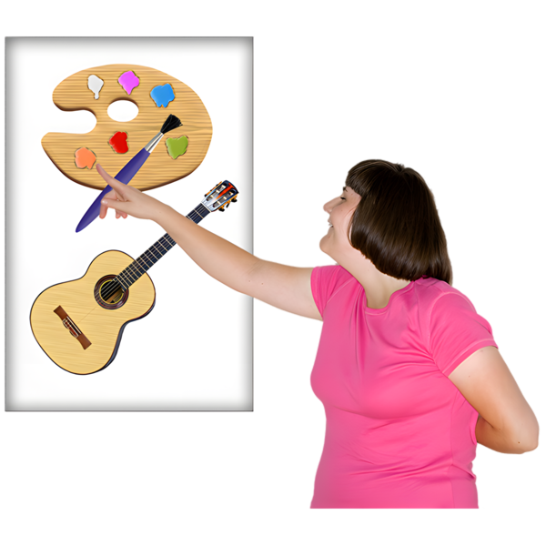Person in pink shirt pointing at a display with a palette and guitar. | Do your carers do exactly what you want them to do? | Choose from ….  ☐ Yes  ☐ No  ☐ Don’t know  Or write something to explain here  ……………………………………………………………………
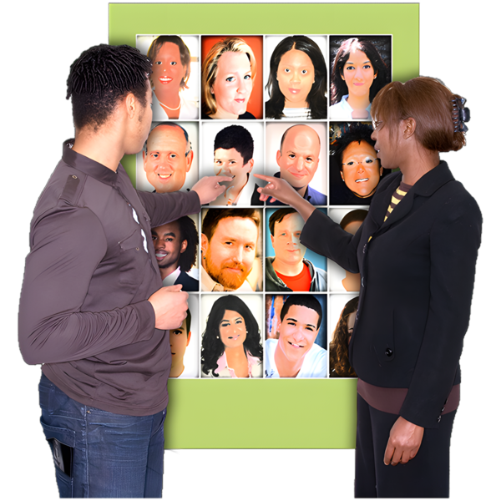Two people choosing who they want as carers | Can you change your carers if you want? | Choose from ….  ☐ Yes  ☐ No  ☐ Don’t know  Or write something to explain here  ……………………………………………………………………

Section 4 - What Good Care Looks Like

A smiling man pointing at the camera in front of a background with colorful squares and question marks. | What do you like most about your carers? | Please write a word down that explains how you feel  ……………………………………………………………………
Man with a distressed expression and hand on chest with the caption 'Don't Like'. | What do you not like about your carers? | Please write a word down that explains how you feel  ……………………………………………………………………
Woman seated at a table raising her hand up. | What is most important to you about your care? | Choose from …  ☐ Respect  ☐ Dignity  ☐ Independence  ☐ Choice  ☐ Control  ☐ Trust  ☐ Being listened to  ☐ Reliability  ☐ Safety  ☐ Flexibility  ☐ Privacy  ☐ Good communication  ☐ Emotional support  ☐ Feeling valued  ☐ Consistency  Or write something else here  ………………………………………………………….

Section 5 - When Care Changes or Goes Wrong
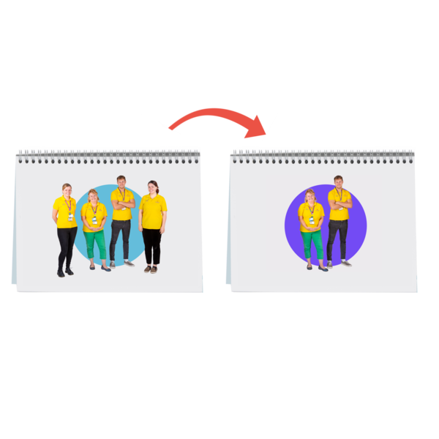Two flip chart pages showing a group of people transitioning to a pair. | Has your care ever changed from good to bad | Choose from ….  ☐ Yes  ☐ No  ☐ Don’t know  Or write something to explain here  ……………………………………………………………………
Person in brown t-shirt giving a thumbs-down with a frowning red emoji beside them. | Have you ever complained about your carers? | Choose from ….  ☐ Yes  ☐ No  ☐ Don’t know  Or write something to explain here  ……………………………………………………………………
Two people having a serious conversation, one with a grey jumper and the other with braided hair. | If you complained did anything change? | Choose from ….  ☐ Yes  ☐ No  ☐ Don’t know  Or write something to explain here  ……………………………………………………………………
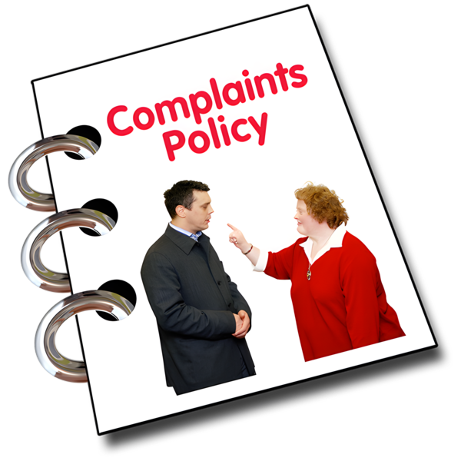A complaints policy booklet with a photo of a woman pointing at a man. | Have you ever wanted to complain but decided not to? | Choose from ….  ☐ Yes  ☐ No  ☐ Don’t know  Or write something to explain here  ……………………………………………………………………

Section 6 - What Needs to Change?

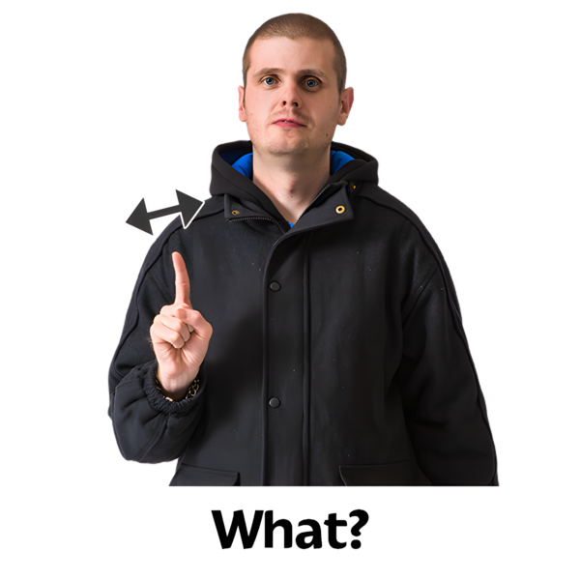Man pointing upwards with the caption 'What?' below. | If you could change anything about your carers, what would it be? | Please write a word down that explains how you feel  ……………………………………………………………………
Three-tiered podium with numbers 1, 2, and 3 in red, orange, and blue colors. | If someone was designing your care, what is the most important thing they should do? | Please write a word down that explains how you feel  ……………………………………………………………………
Three people engaged in a discussion, with an older seated man flanked by two standing individuals gesturing. | Is there anything else you want to say about care and caring? | Please write a word down that explains how you feel  ……………………………………………………………………

Person with a speech bubble saying thank you.

