Difference
Access Guide

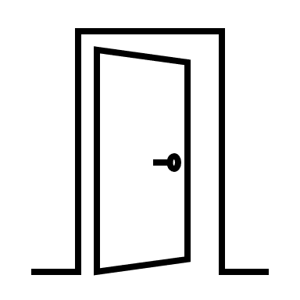

Crowne Plaza Hotel
Accessibility

Difference North East advocate for accessibility to be at the heart of every event. We want to be able to take part in all that life offers, whether we have an impairment or not.

We hope that this document contains the access information you might need about attending the Disability at Work summit.

This guide does not stand in for asking what you need. We will contact you to ask about your specific access needs.

We look forward to welcoming you.

Getting to the venue
The Crowne Plaza Hotel- Stephenson Quarter, Hawthorn Square, Forth Street, Newcastle Upon Tyne NE1 3SA

Public Transport
The Crowne Plaza Hotel is close to Newcastle Central train and Metro stations.
Directions from the station by foot or wheels:
- This journey is 0.4 miles. It will take at least 7 minutes.
- Turn left out of the station onto Neville Street.
- Turn left onto Central Parkway, passing the Life Science Centre.
- At the end of the path, turn left again and pass through the tunnel onto Forth Street.
- Continue straight ahead and the Crowne Plaza Hotel will be to your right. Cross the road at the pedestrian crossing.

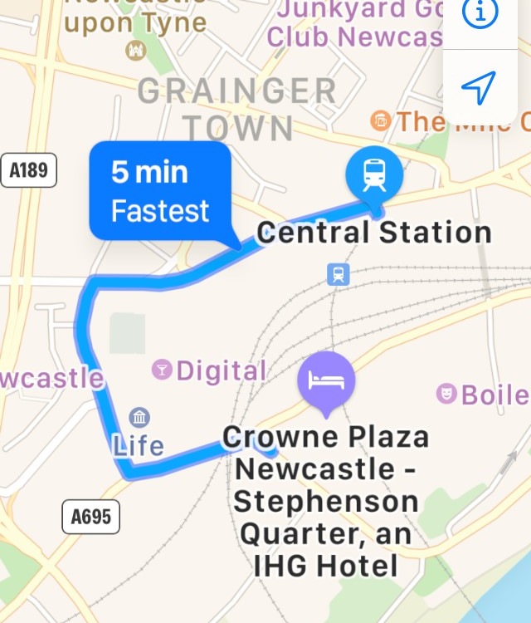
Note: you can also get there by turning right out the station, then right again through the longer tunnel on Orchard Street. At the end of the tunnel, turn right onto Forth Street and continue to the venue. The above route has less traffic noise and has a more even ground surface.

By Car
From Newcastle Central Station turn left onto Neville Street/A186 Left onto Marlborough/A695 (The South A1M, Gateshead A189, Blaydon) Left at the lights onto B1600 (Quayside) Under the bridge then left. The hotel is on the right. There is a drop off point adjacent to the entrance. The car park is down the hill, on the left.

Parking
The closest car park is Stephenson Quarter multi-storey car park located on Forth Street behind the hotel. Come out on level 10 and that brings you to the reception level. We will reimburse parking charges so please keep a receipt/ticket to claim that expense back.

Getting in and moving around
The Disability at Work Summit will take place in the Locomotion 1 and 2 Rooms on the first floor. These rooms join to make one large room. You can see what the room looks like here. It will be set up slightly differently on the day. There will be fewer tables and more space to move around. We will be suing large round ‘cabaret’ style tables with chairs that have supportive back rests. You are, of course, free to move around the space as you feel comfortable.

Entering the Venue
You will enter the hotel through double automatic doors at the front of the building. The entrance is level access to the street. You can view a floorplan of the ground floor here.

Step free access
The room we will be working in is on the first floor accessed by lift. You can view a floor plan of floor 1 here. The lift is directly in front of the entrance. All ramps are of a gentle gradient.

Space to move around
The hotel corridors are wide. We will be using a large mezzanine area as a space to have refreshments. We can also use this space for quiet time outside of the main room. There are multiple types of seating in the space. You can view a panoramic photo of the mezzanine area here.

Signposts
There will be a sign upon entry directing you the room we will be in for the day. Toilets are clearly signposted. A member of Difference NE will be there to greet you upon entry too.

Lifts
There are two lifts directly opposite the main entrance.

Facilities

Accessible Toilet
There is an accessible toilet directly outside our room. This is not a Changing Places toilet and does not have a hoist.

Fire Alarms
There are visual and audio alarms in all the hallways and public areas.

Loop System
There is a loop system in the venue and the room we will be using. We can turn this on if you need it.

Catering for special diets
The venue can cater for all dietary requirements. We will speak with you individually about your dietary requests. You can view a sample menu here to get an idea of what food will be on offer on the day.

Eating and Dining
We will serve food in the restaurant on the ground floor. Of course, you are welcome to take your food and eat elsewhere in the venue, and there are also tables outside the front. We will serve food as a buffet, but hotel staff are available to serve you at a table if this works best for you. Tables will be set out to sit people in 2’s, 4’s and 6’s with comfortable chairs with supportive back rests. We note that this type of dining might make some people feel uncomfortable, especially with others that we might not know very well. You are welcome to eat wherever and however you like. We also aim to make everyone feel comfortable and welcome. You can contact Nic to talk about any element of dining and eating.
You can view the layout of the restaurant here. There are toilets directly next to this dining space. The restaurant has wide walkways between tables.
This venue sells alcohol.

Gender Neutral Toilets
The accessible toilets at the venue are all-gender toilets. Otherwise, the toilets there are gendered as male/female.

Environmental Factors

Covid-19 Safety
The venue is large and open plan. This means that we can practice some social distancing. We have reduced the room capacity from 80 to 50 so that we can have more space to move around. We encourage participants to wear a mask if they want to do so. There is hand sanitiser available throughout the venue. We will supply lots of pens and stationery, so that we do not share these. The doors to the room we are using are fire doors and need remain closed. There are two doorways into the room so we will enter and exit as 2 smaller groups through these to avoid crowding. There is an air conditioning system that brings in fresh air to the room which we will use. We will take regular breaks out of the main room, and you are welcome to leave the space at any time you need to.

Lighting
The room we are using has floor to ceiling windows. We can control the level of light by closing or opening the blinds on these windows. There are spotlights in the ceiling. There will also be two large screens in use for participants accessing the room via zoom. There will be limited interaction with these screens for those attending in person. If you do not want the screen to be visible to you, there is space to sit facing away from them.

Temperature control
We can change the settings of the air conditioning in the room to make sure the temperature is comfortable. We encourage you to put your wellbeing first and you are welcome to come and go into the space as you need to.

Allergens/ Asthma Triggers
To our knowledge, there is not likely to be anything in the venue that triggers asthma or hay fever. There has been building work going on opposite the venue for some time, so there may be some dust from this outside. If you have concerns about allergens, please contact Nic to discuss.

People using the venue at the same time as us
As the venue is a hotel, there will be other people using it at the same time as us. There are other conference and meeting rooms on the same floor as the room we will be using. However, these rooms are on a different corridor so we should not cross over too much with others. There are no hotel rooms on this floor.

Extra spaces

Quiet space
We will use the mezzanine space/breakout area for our breaks and for refreshments. However, during our work together as a group, you are welcome to use this area as a quiet space if you need to leave the group. There are other quiet communal spaces in the hotel, and we can try and make extra arrangements if you let us know in advance of needing this.

Low input space
We do not have a designated low input space. However, we are in discussion with the venue about how we might designate one. Please contact Nic in the meantime if you know will need this. We will update this guide with information as we get it.

High input area
Although we do not have a designated ‘high input’ area, you are welcome to move around the space as much as you need to during the day. If you need somewhere to be more energetic, move around and make noise to give yourself enough stimulation or to release energy, please feel free to do this wherever you feel comfortable to do so. You can also contact Nic to discuss anything that you need to be in place.

Contact information
You can contact Nic or Richard from Difference North East by email, text, or phone call. Please contact us ASAP to discuss any access information you need that we have missed.
Nic@differencenortheast.org.uk / 07944 385409
Richard@differencenortheast.org.uk / 07498 317352

During the Event
We will check in with people during the event to find out whether you need any adjustments while we are there. We will then do our best to make them happen.

